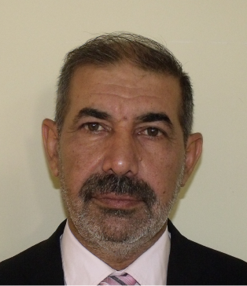
Khalil A. Hussen Al-Jurany
PhD in psychology personality
Diyala-Iraq
009647510143827 / 009647723821459
aljurany@yahoo.com
Khalil A. Hussen (0009-0007-0130-4339) - ORCID

Education
- Heriot-Watt University, United Kingdom 2009 to 2013
PhD in personality psychology
- Al-Mustansiriyah University, Iraq 1992 to 1994
M.A. Degree in Psychology.
- Al-Mustansiriyah University, Iraq 1986 to 1991
B.A. Degree in Psychology
Work Experience
- Al-Mustansiriyah University/ Psychology department., Iraq 1995 to 1996
- Lecturer
- Teaching a general and introduction psychology.
- Nasir university/ psychology Department., Libya 1996 to 2005
- Lecturer – teaching different subjects in psychology e.g. personality theories, social psychology, clinical psychology, education psychology, cognitive psychology, pathological psychology and business psychology.
- Diyala university/ department of psychology counseling and education Guldance., Iraq.
- Lecturer
- Teaching counseling in psychology, psychology, psychopathology, personality and behavior.
Skills
- Lecturer with over 14 year's valuable experience at three universities.
- Confident user of Microsoft Office, including Excel, Word, and Power point.
- I am an accomplished user of statistical analysis (SPSS).
- Good experience in undergraduate supervision.
- A member of Iraqi psychological Association.
- A member of the Iraqi Teachers Association.
- Successfully complete the learning Enhancement and Development Skills (LEADS).

Publishing
- The relationship between PTSD, coping strategies and sense of coherence in an Iraqi representative sample. Alfateh mag. Iraq. 2016.
- What the effect of trauma on your life-qualitative study in Iraq, Bagdad, 2017.
- An analytical study of post traumatic stress disorder in children exposed to trauma in Iraq. Route Educational and Social Science Journal, Volume 5(2) February 2018.
- Post traumatic stress disorder (PTSD) and its correlation with health-related personality traits and aggressive behavior on the sample of university’s students. Nasaq journal Diyala.2018.
- Autism and its relationship with post-traumatic stress disorder and some biographical variables. Journal of Educational and Psychological Sciences
2021, Volume 143, Issue 1, Pages 308-333
- Boredom at Workplace and its Correlation with Big Five Personality Traits.
Al-Fatih journal, 2023, Volume 19, Issue 2, Pages 299-321.
- The Relationship Between the Big-5 Personality Traits and Satisfaction with Life in Iraqi Sample exposed to COVID-19 infection. Diyala Journal of Human Research, 2023, Volume 1, Issue 96, Pages 228-246.

Published thesis:
- Personality characteristic trauma and PTSD symptoms: population study. A PhD thesis 2016, Germany. http://www.orellfuessli.ch/shop/home/artikeldetails/personality_characteristic_trauma_and_ptsd_symptoms_population_s/khalil_aljurany/ISBN3-659-84105-6/ID46783036.html.

Books:

- An introduction to post-traumatic stress disorder. Aldar Aljamaa for printing, publishing and translation. Baghdad 2018, Iraq.

